


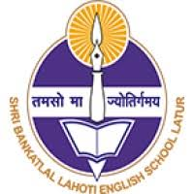
Shri Marwadi Rajasthan Shikshan Sanstha’s
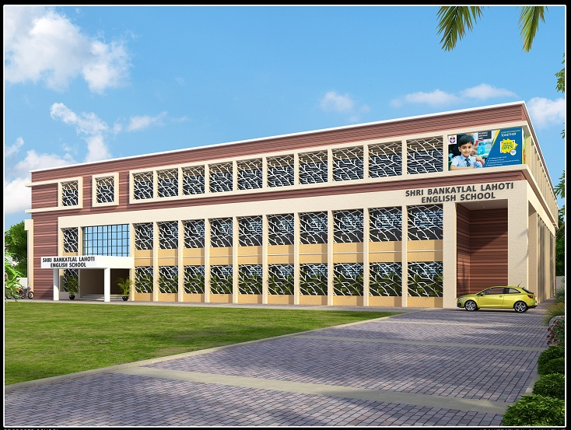
Shri Bankatlal Lahoti English School, Latur

SBLES Repertoire 2026 -27

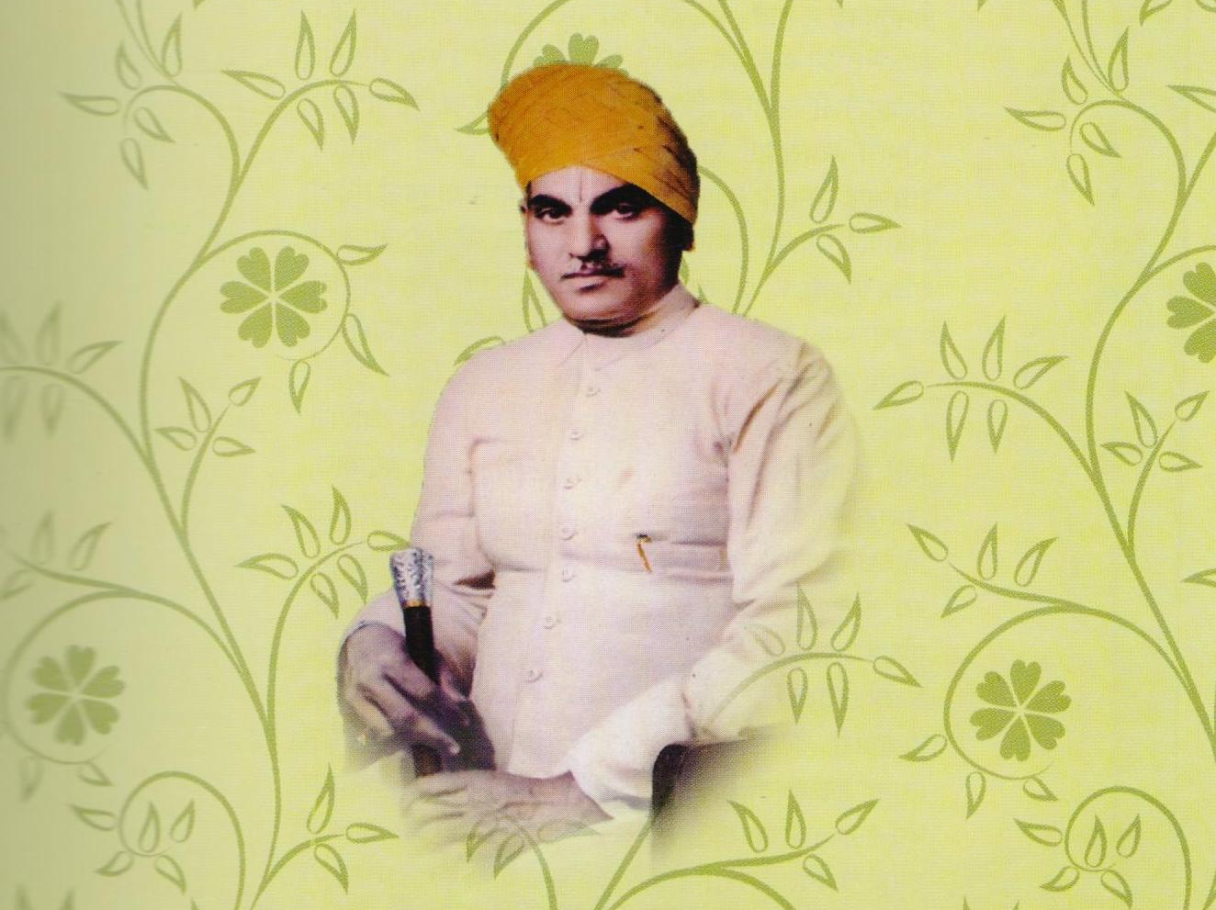
SBLES Repertoire 2026 -27

The Prophet behind the Vision
Late Shri Bankatlalji Lahoti

- List of Holidays
- Segment wise Assessment/Examination Schedule
- Segment wise Inter House Competitions
- Segment wise Co-Curricular Activities
- Segment wise Subject Enrichment Activities
- List of Common Events/Celebrations/Activities for the School

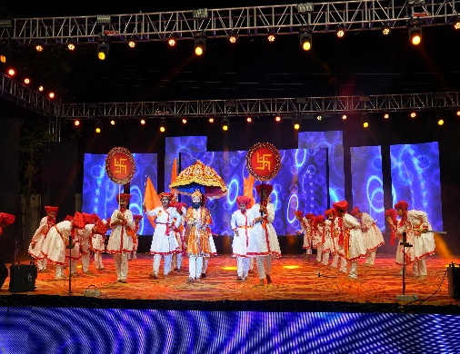
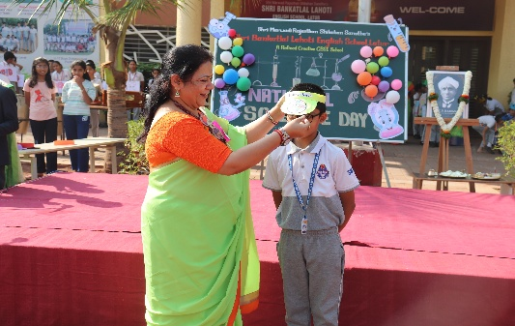
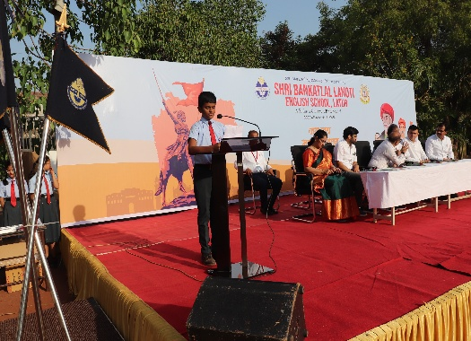
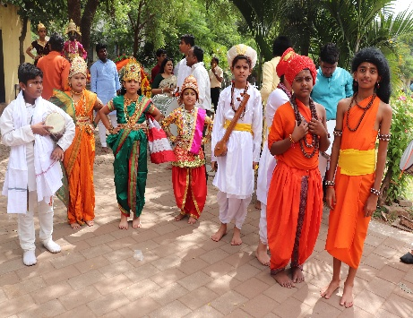
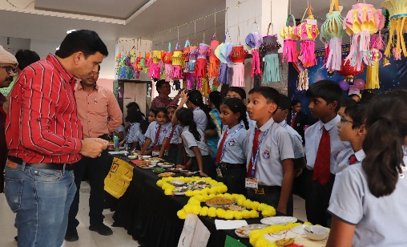
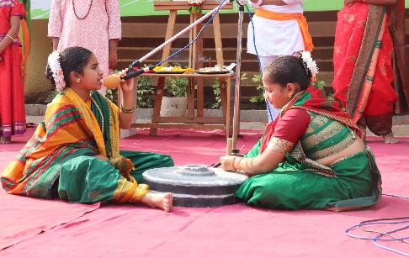

LIST OF HOLIDAYS FOR THE SESSION 2026-27
Sr. No. |  | Date | Day | Details
01 |  | 14th Apr ‘26 | Tuesday | Ambedkar Jayanti
02 |  | 25th Apr ‘26 |  | 4th Saturday
03 |  | 1st May ‘26 | Friday | Maharashtra Day
Vacation: Class I to VIII: 2nd May ‘26 to 7th June ‘26 Class IX & Class X: 2ndMay ‘26 to 31st May ‘26 Sunday
04 |  | 26th Jun ‘26 | Friday | Moharram
05 |  | 27th Jun ‘26 |  | 4th Saturday
06 |  | 25th Jul ‘26 | Saturday | Ashadhi Ekadashi
07 |  | 15th Aug ‘26 | Saturday | Independence Day
08 |  | 22nd Aug’26 |  | 4th Saturday
09 |  | 26th Aug ‘26 | Wednesday | Eid-E-Milad
10 |  | 28th Aug ‘26 | Friday | Raksha Bandhan
11 |  | 14th Sept ‘26 | Monday | Shri Ganesh Chaturthi/Hartalika
12 |  | 15th Sept ‘26 | Tuesday | Rishi Panchami
13 |  | 17th Sept ‘26 | Thursday | Marathwada Mukti Sangram din
14 |  | 18th Sept ‘26 | Friday | Gouri Poojan
15 |  | 19th Sept ‘26 | Saturday | Gouri Visarjan
16 |  | 25th Sept ‘26 | Friday | Anant Chaturdashi
17 |  | 26th Sept ‘26 |  | 4th Saturday
18 |  | 02nd oct ‘26 | Friday | Gandhi Jayanti
19 |  | 20th oct ‘26 | Tuesday | Dussehra
20 |  | 24th oct ‘26 |  | 4th Saturday
Diwali Vacation 05th Nov ’26 Thursday to 15th Nov ’26 Sunday
21 |  | 24th Nov ‘26 | Tuesday | Guru Nanak Jayanti
22 |  | 28th Nov ‘26 |  | 4th Saturday
23 |  | 08th Dec ‘26 | Tuesday | Vela Amavasya
24 |  | 25th Dec ‘26 | Friday | Christmas
25 |  | 26th Dec ‘26 |  | 4th Saturday
26 |  | 15th Jan ‘27 | Friday | Makar Sankranti
27 |  | 23rd Jan ‘27 |  | 4th Saturday
28 |  | 26th Jan ‘27 | Tuesday | Republic Day
29 |  | 19th Feb ‘27 | Friday | Shivaji Maharaj Jayanti
30 |  | 27th Feb ‘27 |  | 4th Saturday
31 |  | 06th Mar ‘27 | Saturday | Mahashivratri
32 |  | 10th Mar ‘27 | Wednesday | Ramadan Eid
33 |  | 26th Mar ‘27 | Friday | Good Friday
34 |  | 27th Mar ‘27 |  | 4th Saturday

Examination Schedule Grade I to VII
Exam | Date | Day | I | II | III | IV | V | VI | VII
Periodic Test1 | 06/07/26 | Monday | - | - | PT1 | PT1 | PT1 | PT1 | PT1
Periodic Test1 | 07/07/26 | Tuesday | PW | PW | PT1 | PT1 | PT1 | PT1 | PT1
Periodic Test1 | 08/07/26 | Wednesday | PW | PW | PT1 | PT1 | PT1 | PT1 | PT1
Periodic Test1 | 09/07/26 | Thursday | PW | PW | PT1 | PT1 | PT1 | PT1 | PT1
Periodic Test1 | 10/07/26 | Friday | PW | PW | PT1 | PT1 | PT1 | PT1 | PT1
Periodic Test1 | 11/07/26 | Saturday | PW | PW | PT1 | PT1 | PT1 | PT1 | PT1
Periodic Test1 | 13/07/26 | Monday | PW | PW | PT1 | PT1 | PT1 | PT1 | PT1
Open - House :21/07/26, Tuesday
Half Yearly Examination | 26/09/26 | Saturday | - | - | HY | HY | HY | HY | HY
Half Yearly Examination | 28/09/26 | Monday | HY | HY | HY | HY | HY | HY | HY
Half Yearly Examination | 29/09/26 | Tuesday | HY | HY | HY | HY | HY | HY | HY
Half Yearly Examination | 01/10/26 | Thursday | HY | HY | HY | HY | HY | HY | HY
Half Yearly Examination | 03/10/26 | Saturday | HY | HY | HY | HY | HY | HY | HY
Half Yearly Examination | 05/10/26 | Monday | HY | HY | HY | HY | HY | HY | HY
Half Yearly Examination | 07/10/26 | Wednesday | HY | HY | HY | HY | HY | HY | HY
Half Yearly Examination | 09/10/26 | Friday | HY | HY | HY | HY | HY | HY | HY
Open - House 23.10.2026; Saturday
Periodic Test 2  Periodic Test 2 | 03/12/26 | Thursday | PW | PW | PT2 | PT2 | PT2 | PT2 | PT2
Periodic Test 2  Periodic Test 2 | 05/12/26 | Saturday | PW | PW | PT2 | PT2 | PT2 | PT2 | PT2
Periodic Test 2  Periodic Test 2 | 07/12/26 | Monday | PW | PW | PT2 | PT2 | PT2 | PT2 | PT2
Periodic Test 2  Periodic Test 2 | 08/12/26 | Tuesday | PW | PW | PT2 | PT2 | PT2 | PT2 | PT2
Periodic Test 2  Periodic Test 2 | 09/12/26 | Wednesday | PW | PW | PT2 | PT2 | PT2 | PT2 | PT2
Periodic Test 2  Periodic Test 2 | 10/12/26 | Thursday | PW | PW | PT2 | PT2 | PT2 | PT2 | PT2
Periodic Test 2  Periodic Test 2 | 12/12/26 | Saturday | PW | PW | PT2 | PT2 | PT2 | PT2 | PT2
Open - House :19/12/26; Saturday
Annual Examination | 01/03/27 | Monday | - | - | AE | AE | AE | AE | AE
Annual Examination | 03/03/27 | Wednesday | AE | AE | AE | AE | AE | AE | AE
Annual Examination | 05/03/27 | Friday | AE | AE | AE | AE | AE | AE | AE
Annual Examination | 08/03/27 | Monday | AE | AE | AE | AE | AE | AE | AE
Annual Examination | 11/03/27 | Thursday | AE | AE | AE | AE | AE | AE | AE
Annual Examination | 13/03/27 | Saturday | AE | AE | AE | AE | AE | AE | AE
Annual Examination | 15/03/27 | Monday | AE | AE | AE | AE | AE | AE | AE
Annual Examination | 17/03/27 | Wednesday | AE | AE | AE | AE | AE | AE | AE
Annual Examination | 18/03/27 | Thursday | AE | AE | AE | AE | AE | AE | AE
Open - House: 25th Mar (I & II) ,27th (III & IV) ,29th (V & VI), 30th Mar ‘27 (VII & VIII)
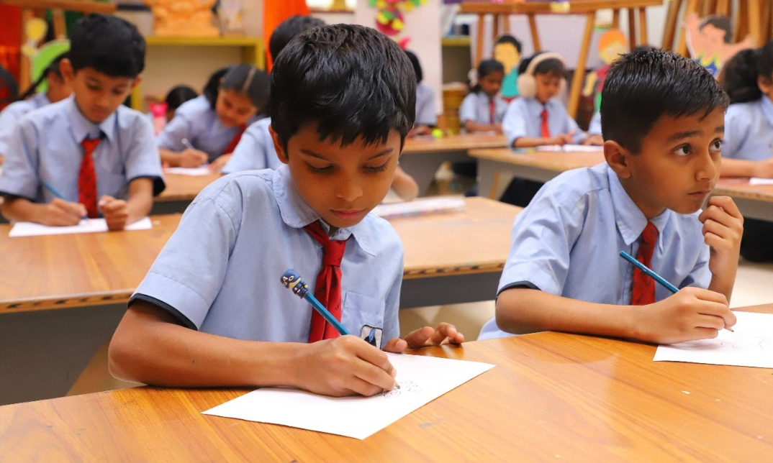

Note – • PT :- Periodic Test • PW :- Practice Worksheet • HY :- Half Yearly • AE :- Annual Exam

Examination Schedule Grade VIII
Exam | Date | Day | VIII
Periodic Test 1 | 06/07/26 | Monday | PT1
Periodic Test 1 | 07/07/26 | Tuesday | PT1
Periodic Test 1 | 08/07/26 | Wednesday | PT1
Periodic Test 1 | 09/07/26 | Thursday | PT1
Periodic Test 1 | 10/07/26 | Friday | PT1
Periodic Test 1 | 11/07/26 | Saturday | PT1
Periodic Test 1 | 13/07/26 | Monday | PT1
Open - House :21/07/26, Tuesday
Half Yearly Examination  Term -1 | 26/09/26 | Saturday | HY
Half Yearly Examination  Term -1 | 28/09/26 | Monday | HY
Half Yearly Examination  Term -1 | 29/09/26 | Tuesday | HY
Half Yearly Examination  Term -1 | 01/10/26 | Thursday | HY
Half Yearly Examination  Term -1 | 03/10/26 | Saturday | HY
Half Yearly Examination  Term -1 | 05/10/26 | Monday | HY
Half Yearly Examination  Term -1 | 07/10/26 | Wednesday | HY
Half Yearly Examination  Term -1 | 09/10/26 | Friday | HY
Open - House 23.10.2026; Saturday
Periodic Test 3 | 03/12/26 | Thursday | PT3
Periodic Test 3 | 05/12/26 | Saturday | PT3
Periodic Test 3 | 07/12/26 | Monday | PT3
Periodic Test 3 | 08/12/26 | Tuesday | PT3
Periodic Test 3 | 09/12/26 | Wednesday | PT3
Periodic Test 3 | 10/12/26 | Thursday | PT3
Open - House 12/12/26; Saturday
Annual Examination | 18/02/27 | Friday | AE
Annual Examination | 20/02/27 | Saturday | AE
Annual Examination | 22/02/27 | Monday | AE
Annual Examination | 24/02/27 | Wednesday | AE
Annual Examination | 26/02/27 | Friday | AE
Annual Examination | 01/03/27 | Monday | AE
Annual Examination | 03/03/27 | Wednesday | AE
Annual Examination | 05/03/27 | Friday | AE
Open - House 13/03/2027; Friday
Note:- • PT:- Periodic Test • HY :- Half Yearly • PFT :- Pre-Final Test • Prac. T :- Practice Test • AE :- Annual Exam

Examination Schedule Grade IX and X
Exam | Date | Day | IX | Exam | Date | Day | X
Periodic Test 1 | 20/06/26 | Saturday | PT1 | Periodic Test 1 | 06/06/26 | Saturday | PT1
Periodic Test 1 | 22/06/26 | Monday | PT1 | Periodic Test 1 | 08/06/26 | Monday | PT1
Periodic Test 1 | 23/06/26 | Tuesday | PT1 | Periodic Test 1 | 09/06/26 | Tuesday | PT1
Periodic Test 1 | 24/06/26 | Wednesday | PT1 | Periodic Test 1 | 10/06/26 | Wednesday | PT1
Periodic Test 1 | 25/06/26 | Thursday | PT1 | Periodic Test 1 | 11/06/26 | Thursday | PT1
Periodic Test 1 | 29/06/26 | Monday | PT1 | Periodic Test 1 | 12/06/26 | Friday | PT1
Open - house 11/07/2026; Saturday |  |  |  | Open - House 20/06/2026; Saturday
Half Yearly Examination  Term -1 | 17/08/26 | Monday | HY | Half Yearly Examination  PT-2 | 27/07/26 | Monday | HY
Half Yearly Examination  Term -1 | 19/08/26 | Wednesday | HY | Half Yearly Examination  PT-2 | 29/07/26 | Wednesday | HY
Half Yearly Examination  Term -1 | 21/08/26 | Friday | HY | Half Yearly Examination  PT-2 | 31/07/26 | Friday | HY
Half Yearly Examination  Term -1 | 24/08/26 | Monday | HY | Half Yearly Examination  PT-2 | 01/08/26 | Wednesday | HY
Half Yearly Examination  Term -1 | 25/08/26 | Tuesday | HY | Half Yearly Examination  PT-2 | 03/08/26 | Monday | HY
Half Yearly Examination  Term -1 | 27/08/26 | Thursday | HY | Half Yearly Examination  PT-2 | 05/08/26 | Wednesday | HY
Open - House 12/09/26; Saturday |  |  |  | Open - House 18/08/26; Tuesday
Periodic Test 3 | 19/11/26 | Thursday | PT3 | Periodic Test 3 | 26/09/26 | Saturday | PT3
Periodic Test 3 | 21/11/26 | Saturday | PT3 | Periodic Test 3 | 28/09/26 | Monday | PT3
Periodic Test 3 | 23/11/26 | Monday | PT3 | Periodic Test 3 | 30/09/26 | Wednesday | PT3
Periodic Test 3 | 25/11/26 | Wednesday | PT3 | Periodic Test 3 | 01/10/26 | Thursday | PT3
Periodic Test 3 | 27/11/26 | Friday | PT3 | Periodic Test 3 | 03/10/26 | Saturday | PT3
Periodic Test 3 | 30/11/26 | Monday | PT3 | Periodic Test 3 | 05/10/26 | Monday | PT3
Open - House 12/12/26; Saturday |  |  |  | Open - House 17/10/26; Saturday
Pre-final Exam | 09/01/27 | Saturday | PFT | Practice Exam - 1 | 12/12/26 | Saturday | Pr E-1
Pre-final Exam | 11/01/27 | Monday | PFT | Practice Exam - 1 | 14/12/26 | Monday | Pr E-1
Pre-final Exam | 13/01/27 | Wednesday | PFT | Practice Exam - 1 | 15/12/26 | Tuesday | Pr E-1
Pre-final Exam | 15/01/27 | Friday | PFT | Practice Exam - 1 | 16/12/26 | Wednesday | Pr E-1
Pre-final Exam | 16/01/27 | Saturday | PFT | Practice Exam - 1 | 17/12/26 | Thursday | Pr E-1
Pre-final Exam | 18/01/27 | Monday | PFT | Practice Exam - 1 | 19/12/26 | Saturday | Pr E-1
Annual Examination | 06/02/27 | Saturday | AE | Practice Exam -2 | 01/01/27 | Friday | Pr E-2
Annual Examination | 08/02/27 | Monday | AE | Practice Exam -2 | 02/01/27 | Saturday | Pr E-2
Annual Examination | 10/02/27 | Wednesday | AE | Practice Exam -2 | 04/01/27 | Monday | Pr E-2
Annual Examination | 12/02/27 | Friday | AE | Practice Exam -2 | 06/01/27 | Wednesday | Pr E-2
Annual Examination | 15/02/27 | Monday | AE | Practice Exam -2 | 08/01/27 | Friday | Pr E-2
Annual Examination | 17/02/27 | Wednesday | AE | Practice Exam -2 | 09/01/27 | Saturday | Pr E-2
Open - House 26/02/2027; Friday |  |  |  | Pre-final Exam | 16/01/27 | Saturday | PFE
 |  |  |  | Pre-final Exam | 18/01/27 | Monday | PFE
 |  |  |  | Pre-final Exam | 20/01/27 | Wednesday | PFE
 |  |  |  | Pre-final Exam | 22/01/27 | Friday | PFE
 |  |  |  | Pre-final Exam | 25/01/27 | Monday | PFE
 |  |  |  | Pre-final Exam | 27/01/27 | Wednesday | PFE

Note: - • PT: - Periodic Test • HY: - Half Yearly • PFE: - Pre-Final Exam • Pr. E.:- Practice Exam • AE :- Annual Exam
Month | I & II | III & IV | V & VI | VII & VIII | IX | X
June | Who am I | Coloring | Maths around us | Elocution | India heritage quiz | India heritage quiz
June | 24th June | 13th Jun ‘26 | 20th Jun ‘26 | 19th Jun ‘26 | 17th Jun ‘26 | 25th Jun ‘26
July | Coloring | Word Master | Science Quiz | Theme Based Painting | Easy Writing | Theme Based Painting
July | 15th Jul ‘26 | 22nd Jul ‘26 | 22nd Jul ‘26 | 29th Jul ‘26 | 1st Jul ‘26 | 8th Jul ‘26
August | Hand writing | GK Quiz | Heritage India Quiz | Word Master | Street Play on Social Topic | Debate
August | 12th Aug ‘26 | 5th Aug ‘26 | 19th Aug ‘26 | 12th Aug ‘26 | 5th Aug ‘26 | 22nd Aug ‘26
September | Devotional song Recitation | Verse Recitation | Sanskrit verse recitation | Drama | Debate | Essay Writing
September | 23rd Sept ‘26 | 22nd Sept ‘26 | 24th Sept ‘26 | 9th Sept ‘26 | 23rd Sept ‘26 | 30th Sept ‘26
October | Word Master | Lantern Making | Word Master | Power Point Magic | Monologue- Character Talk | Elocution
October | 21st Oct ‘26 | 21st Oct ‘26 | 28th Oct ‘26 | 21st Oct ‘26 | 7th Oct ‘26 | 14th Oct ‘26
November | Fancy Dress | Story Weaving | Diwali Greeting Card Making | Poster Making |  | Drama
November | 3rd Nov ‘26 | 25th Nov ‘26 | 4th Nov ‘26 | 4th Nov ‘26 | - | 25th Nov
January | Story Telling | Solo Singing | Elocution | Collage Making | _ | _
January | 20th Jan ‘26 | 06th Jan ‘27 | 13th Jan ‘27 | 20th Jan ‘27
February | Elocution | Picture Composition | Story Weaving | Science Quiz | _ | _
February | 13th Feb ‘26 | 3rd Feb ‘27 | 10rd Feb ‘27 | 3rd Feb ‘27
INTER HOUSE COMPETITIONS FOR THE SESSION 2026 -27

GRADE WISE CO-CURRICULAR ACTIVITIES SCHEDULE
Day | Class | Period
Thursday-Saturday | IV - VI | 8th
Monday-Wednesday | VII-VIII | 8th

GRADE WISE SUBJECT ENRICHMENT ACTIVITIES
GRADE I-II
April-October | Term - I
November | Diwali Vacation (holiday Assignment/Activities)
November - February | Term - II

GRADE III-V
April-October | Term - I
November | Diwali Vacation (holiday Assignment/Activities)
November - February | Term - II

GRADE VI - VIII
April-October | Term - I
November | Diwali Vacation (holiday Assignment/Activities)
November - February | Term - II

GRADE IX - X
Apr-Aug | Term - I
Sept to Jan | Term - II

LIST OF COMMON EVENTS/CELEBRATIONS/ACTIVITIES FOR THE WHOLE SCHOOL
Sr.No | Date | Day | Celebrations | Events | Activity
 | 10th Apr ‘26 | Thu | - | New Session begins for Class I | New Session begins for Class I
 | 14th Apr ‘26 | Sun |  | Dr.B.R.Ambedkar Jayanti | -
 | 15th Apr ‘26 | Wed |  | International Arts Day
 | 23rd Apr ‘26 | Thu | - | International English Day | -
 | 24th Apr ‘26 | Fri | National Panchayati  Raj Diwas | - | -
 | 1st May ‘26 | Fri | Maharashtra Day | - | -
 | 2nd May to 14th may ‘26 | - |  |  | Teachers Training on NCF
 | 1st Jun ‘26 | Mon |  | School Re-Opens for class IX, X & Staff
 | 2nd Jun to 6th Jun |  | Teachers Enrichment Activity (TEA)
 | 8th Jun ‘26 | Mon | - | School Re-Opens for class I to VIII | Teacher Led Assembly
 | 13th Jun ‘26 |  |  | Theme of S.A.: Environment’s safety Everybody’s duty | Special Assembly (Class VIII - R)
 | 15th Jun ‘26 | Mon |  | Last day to submit profile for Students council Candidature
 | 16th Jun ‘26 | Tue | Foundation Day of the School | - | -
 | 17th Jun ‘26 |  |  |  | Class- monitors Selection
 | 20th Jun ‘26 | Sat | World Yoga Day Celebration | Theme of S.A.: Yoga: Sages to Students | Special Assembly (Class VIII- L)
 | 21st Jun ‘26 | Sun | World Yoga Day | (To be Celebrated on 20th Jun ’26) | -
 | 24 Jun ‘26 | Wed | - |  | Students’ council Selection
 | 25th Jun ‘26 | Thu | Chatrapati Shahu Maharaj Jayanti Celebration | Theme: Social Justice | Special Assembly (Class VIII- T)
 | 01st Jul ‘26 | Wed | National Doctors Day | Theme of S.A.: Compassion, Care & Cure | Special Assembly by Class (X -R)
 | 04th Jul ‘26 | Sat |  | Investiture Ceremony | Teacher Enrichment Activity
 | 09th Jul ‘26 | Sat |  | Theme of S.A.: Jijau | Special Assembly by Class (X -L)
 | 18th Jul ‘26 | Thu |  | Theme of S.A.: Saints of Maharashtra | Special Assembly by Class (X -T)
 |  |  |  |  | Teacher Enrichment Activity
 | 19th Jul ‘26 | Sunday | Death Anniversary of Late Shri Raja Narayanlalji Lahoti |  | -
 | 24th Jul ‘26 | Thu | Ashadhi Ekadashi Vari Celebration |  | -
 | 27th Jul | Mon |  | Theme of S.A.: Victory Day | Special Assembly By class IX - R
 | 29th Jul | Wed | Guru Poornima Celebration
 | 01st Aug ‘26 | Sat |  | Theme of S.A.: Swarajya | Special Assembly By class IX - L
 |  |  |  | Death Anniversary of Lokmanya Tilak  &  Birth Anniversary of Annabhau Sathe | Teacher Enrichment Activity
 | 09th Aug 26’ | Sun | Kranti din: District Level Interschool Singing Competition
 | 11th Aug ‘26 | Tue |  | Theme of S.A.: Unsung heroes of India | Special Assembly By class IX - T
 | 15th Aug ‘26 | Sat | Independence Day | - | -
 | 21st Aug ‘26 | Fri |  | Theme of S.A.: Wonders of Space | Special Assembly By class VII- R
 | 27th Aug ‘26 | Thu | Raksha Bandhan celebration
 | 29th Aug ‘26 | Sat | - | Theme of S.A.: National Sports Day | Special Assembly By class VII - L
 |  |  |  |  | Teacher Enrichment Activity
 | 4th Sept ‘26 | Fri | Dahi - Handi Celebration | - | -
 | 5th Sept ‘26 | Sat | Teacher’s Day Celebration | - | Special Assembly By class VII - T
 | 11th Sept ‘26 | Fri |  | Theme of S.A.: Engineering Miracles | Special Assembly By class VI - R
 | 12th Sept ‘26 | Sat | - | - | Ganpati Idol making Workshop
 | 14th Sept ‘26 | Mon | Shri Ganesh Chaturthi | Hindi Divas | -
 | 17th Sept ‘26 | Thu | Marathwada Liberation Day | - | -
 | 25th Sept ‘26 | Fri | Anant Chaturdashi | - | -
 | 02nd Oct ‘26 | Fri |  | Birth Anniversary of Mahatma Gandhi  &  Lal B. Shastri | -
 | 03rd Oct ‘26 | Sat |  |  | Teacher Enrichment Activity
 | 15th Oct ‘26 | Thu |  | Theme for S. A.: Navdurga | Special Assembly By class VI - R
 | 17th Oct ‘26 | Sat | Garba | - | -
 | 21st Oct ‘26 | Wed |  | Theme for S. A.: Sports Icons | Special Assembly By class VI - R
 | 22nd to 24th Oct ‘26 |  |  | Annual Sports Meet
 | Between 25th oct ’26 to 31st oct | Educational Excursion for Std IX & X
 | Between 28th oct ’26 to 04th Nov | Educational Excursion for Std I & VIII
 | 8th Nov ‘26 | Sun | Lakshmi Poojan | - | -
 | 12th Nov ‘26 | Thu | - | Kavivar Kalidas Jayanti | -
 | 14th Nov ‘26 | Sat | - | Children’s Day | -
 | 16th Nov ‘26 | Mon | School Re-Open
 | 20th Nov ‘26 | Fri |  | Theme for S. A.: Young achievers | Special Assembly By class VI - L
 | 21st Nov ‘26 | Sat |  |  | Teacher Enrichment Activity
 | 26th Nov ‘26 | Thu | - | Theme for S. A.: Constitution Day | Special Assembly By class VI - T
 | 28th Nov ‘26 | Sat | - | Mahatma Phule Jayanti | -
 | 30th Nov ‘26 | Mon |  | Theme for S. A.: Social Reformers | Special Assembly By class V- R
 | 05th Dec ‘26 | Sat |  |  | Teacher Enrichment Activity
 | 15th Dec | tue |  | Theme for S. A.: Save Energy save future | Special Assembly By class V- L
 | 22nd Dec ‘26 | Thu | - | Theme for S. A.: Wonderful maths | Special Assembly By class V- T
 | 25th Dec | Sun | Christmas | - | -
 | 27th Dec ‘26 | Tue | Rhythm-2026 | - | -
 | 2nd Jan ‘27 | Sat | - | Savitribai Phule Jayanti- Balika Din | Teacher Enrichment Activity
 | 05th Jan ‘27 | Tue |  | Theme for S. A.: Countries of the world | Special Assembly By class IV- R
 | 07th Jan ‘27 | Wed | Sanstha’s Foundation Day | - | -
 | 14th Jan ‘27 | Thu |  | Theme for S. A.: Geographical wonders | Special Assembly By class IV- L
 | 16th Jan ‘27 | Sat |  |  | Teacher Enrichment Activity
 | 21st Jan ‘27 | Thu |  | Theme for S. A.: Republic India | Special Assembly By class IV- T
 | 26th Jan ‘27 | Tue | Republic Day | - | -
 | 28th Jan ‘27 | Thu |  | Theme for S. A.: Shaheedon ko naman | Special Assembly By class IV- T
 | 29th Jan ‘27 | Fri | Farewell For Grade X | - | -
 | 30th Jan ‘27 | Sat | - | Death Anniversary of Mahatma Gandhi | -
 | 02nd Feb ‘27 | Tue | - | Death Anniversary of Late Shri Bankatlalji Lahoti | -
 | 04th Feb ‘27 | Thu |  | Theme for S. A.: Women in science | Special Assembly By class III- R
 | 06th Feb ‘27 | Sat |  |  | Teacher Enrichment Activity
 | 10th Feb ‘27 | Wed | Death Anniversary of Late Shri Puranmalji Lahoti | - | -
 | 11th Feb ‘27 | Thu |  | Theme for S. A.: Welcome Spring | Special Assembly By class III- L
 | 18th Feb ‘27 | Thu | Chatrapati Shivaji Maharaj Jayanti Celebration | - | -
 | 20th Feb ‘27 | Sat |  | Theme for S. A.: Rayatecha Raja | Special Assembly By class III- T
 |  |  |  |  | Teacher Enrichment Activity
 | 26th Feb ‘27 | Fri | - | Marathi Day- V.V. Shirwadkar Jayanti | -
 | 28th Feb ‘27 | Sun | - | Birth Anniversary of Dr.C.V. Raman | -
 | 8th Mar ‘27 | Mon | Women's Day celebration | - | -

Note: - CBSE Suggested Activities will be the essential part of our Calendar time to time
Events
Activities
Celebrations

